National Team Event 2017

15 Essex archers descended upon Lillishall National sports centre in Shropshire to take part in this years team event. Saturday was a WA720 followed by team Head to heads and Sunday a full WA 1440. Final team positions were to be decided on all three events.

Saturday the weather was dry, warm with the usual Lillishall breeze, the morning started with the qualifying WA720 round, 6 dozen arrows shot at 70meters for recurve and longbow and 50mtrs for compound, the total score of all three archers per team was added to see were each team was ranked for the afternoon h2h session. At the end of this qualifying round the positions were, compound women 2nd, compound men 5th, recurve men 14th, recurve women 3rd and longbow men 7th.

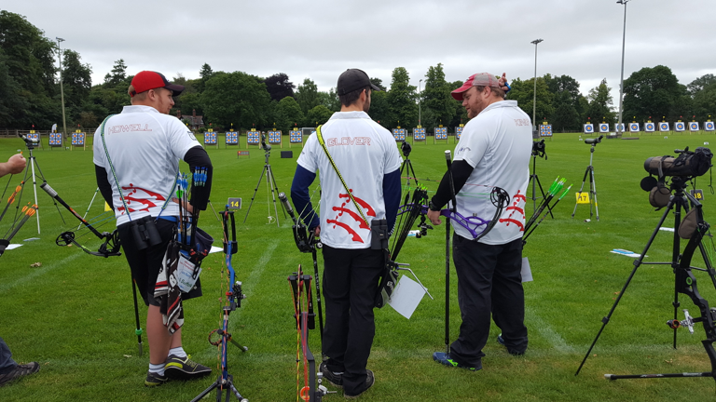
After a break for lunch the Head 2 Heads got underway and ran into late afternoon. The compound men got a bye into the 1/8th only to be denied a spot in the ¼ by the team from Derbyshire.

The compound women shot amazingly well flying past DNA and Gloucestershire to earn a well deserved spot in the gold medal match were they were just edged out by Kent to take 2nd spot. “well done girls, great shooting”
At the recurve end of the field the men demolished Hampshire B team winning 6-0 but unfortunately were knocked out by DNA in the 1/8th . The women beat DWAA in a one arrow shoot off in the 1/8th to have the same thing happen to them in the ¼ against Yorkshire but alas victory was not forth coming. The longbow men came up against 2nd seed DEV but unfortunately lost the match.

The second day began early and the team were pleased to hear they would be shooting 6 arrows all day, the weather was not so good with changeable gusty winds, downpours and cooler temperatures but as usual the Essex Team moral was upbeat considering the conditions, by the time we hit the last distance that all changed with numerous pass throughs taking place at the compound end of the field slowing down the pace the early finish that once was became a bit of a blur. The round finally finished at 5.30pm and everyone felt drained and dreading the 3hr plus journey home.
The compound men finished 3rd for the day, women 4th, recurve men 13th, women 4th and longbow men 5th.

Presentations took place for the weekends combined results which saw our compound women finishing second overall. “Amazing shooting girls”, compound men finished 5th overall, recurve women 4th, recurve men 12th and longbow men 7th.

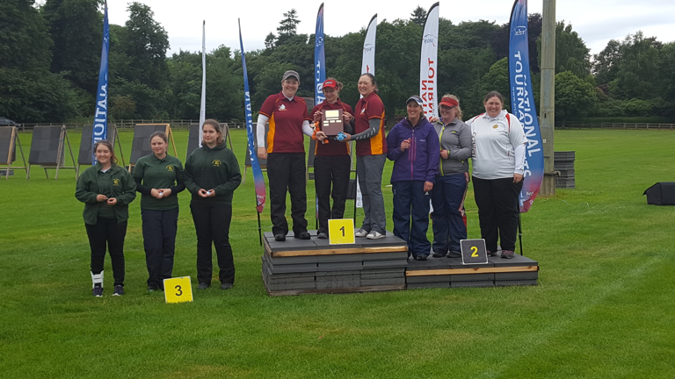

Thank-you to all the team for making my job enjoyable and easy and well done to all who took part, congratulations to our medal placed girls and too our new adult team members Alex Body (debut) and Lauren Bann(debut), I am sure we will see plenty more of you in the adult team going forward.

Full results can be found on ianseo.net or via archerygb website

Lesley a Howell
Essex Team Manager.

