Havering Active Life
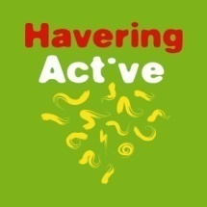
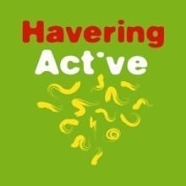
45+ Physical Week
ARCHERY TOURNAMENT
Results
Gentlemen recurve Gentlemen Compound
1 Alan Horn Noak Hill 868 1 John Raffin Noak Hill 902
2 Glenn Rodgers Noak Hill 804 Gentlemen Longbow
3 James Moir Braintree 801 1 Mark Lawrence Noak Hill 567
4 Kevin Sykes West Essex 799 2 Andy Rae Abbey 541
5 Graham Hill West Essex 794 3 Max Room Noak Hill 531
6 Alan Munson Blue Arrows 776 4 Steve Spragg Noak Hill 505
7 Richard Whiteley Braintree 762 5 Eric Mallet Abbey 456
8 Brian Lock Noak Hill 757 6 Bob Riley Racketts 421
9 Ian Saunders Noak Hill 754 108 Hits 7 Tony Bovis West Essex 400
10 Kevin Hammond Abbey 754 106 Hits 8 Tony Maher Oakfield 361
11 Paul Logan Braintree 742 9 Martin Vidgeon Hart Mayflower 353
12 Andy Gillard Blue Arrows 712 10 Kevin Juniper Grays 329
13 Dave Perrin West Essex 648 11 Harry Grove Noak Hill 297
14 Alan Cook West Essex 624 12 Bob Francis Abbey 292

Ladies Longbow
1 Sharon Lawrence Noak Hill 517
Over 65 Recurve
Team 1 Kevin Sykes West Essex 799
Alan Horn Noak Hill 868 2 Graham Hill West Essex 794
Glenn Rodgers Noak Hill 804 3 Dave Perrin West Essex 648
Brian Lock Noak Hill 757 4 Alan Cook West Essex 624
2429
Best Gold – John Raffin

James Moir Braintree 801 Worst White – Kevin Sykes
Richard Whiteley Braintree 762
Paul Logan Braintree 742 Lord Patrons prize - Martin Vidgeon Hart
2305

Special thanks must go to all the members of Abbey Bowmen for all of their help both on the day and prior to the tournament.
To the ladies of Abbey Bowmen, in particular, who kept us so well fed and watered throughout the day.

To my wife Maggie, who did most of the leg work and had to put up with my constant whinging.
& our Lord Patron Jonathan Neal

The scoring team of Jonathan Neal & Mrs Maggie Pearce

And lastly, but by no means least to everyone who turned up and made it such an enjoyable and successful day.

Many Thanks; Mick Pearce – Organiser

