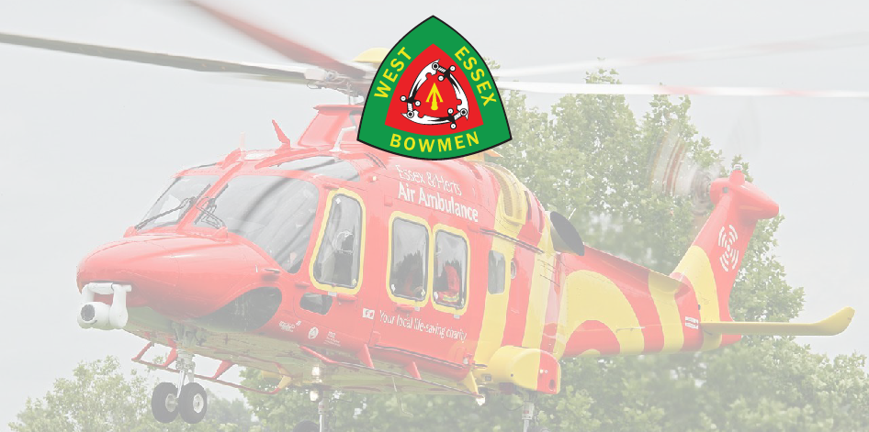
WEST ESSEX BOWMEN
Annual World Record Status
Double Double 70m/60m/50m WA720
In aid of the ESSEX & HERTS Air Ambulance Trust
Date: Saturday 25th April and Sunday 26th April 2026
Round: Double 70m/60m/50m WA 720 Round each Day (WRS)
Venue: Belhus Woods Country Park, Romford Road
Aveley, ESSEX, RM15 4XJ
Judges: TBC
Paramount: Mr Malcome Jones
Assembley 08:30am each day
Practice : 08:45am each day
Fee/Donation: £15:00 a day - £10 is donated to the ESSEX and HERTS Air Ambulance Trust (RC 1108989)
Cheques made payable to West Essex Bowmen or Bank Transfer to
Sort Code 20-72-89 Acc No.80956082, include surname of Archer in payment reference
Rules: The competition will be run under AGB rules, proof of membership will be required
Car Parking: Parking anywhere on the Belhus site costs £6:80 (correct at time of publication)
TITLE | NAME | M/F | Round 70/60/50 | Snr/Jnr | AGB No. | R – C- LB - BB | Sat/Sun/Both
 |  |  |  |  |  | TOTAL

Club: ……………………………………………………… Date: ………………………………………….
Email: …………………………………………………… Tel: …………………………………………….
Address: ………………………………………………………………………………………………………….
Completed entry forms to be emailed to: tolson730@btinternet.com
Or posted to: Paul Tolson, 315 Parkmill Close, Corringham, ESSEX, SS17 7JR
Tel: Paul 07926703788 Dawn 07592432482
Disclaimer: Neither WEST ESSEX BOWMEN, ESSEX & HERTs Air Ambulance, Essex County Council their agents and servants cannot accept any responsibility for any loss damage or injury howsoever caused
No Dogs are Allowed - unless Guide Dogs or Assistance Dogs
By completing the form or signing up to the competition you are agreeing to our privacy policy which can be found at: www.westessexbowmen.co.uk/privacy-policy

