Ascham Bowmen
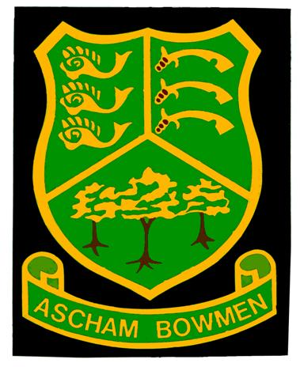
43RD OPEN - COOKE SUMMER SHOOT
Sunday 31st July 2022
ALBION & WINDSORS
Venue: "The Park", Rivenhall Gardens, Snaresbrook, London E18 2BT
Sighters: 10.30 am.
Entry fee: £8.00 Adults, £5.00 Juniors; includes tea, coffee and cake at lunch break.
Closing date: 25th July 2022 (or when full)
Adult rounds: Albion, Windsor and Short Windsor
Junior rounds: Windsor, Short Windsor, Junior Windsor and Short Junior Windsor
Recurve team of four: to include at least one lady (Albion).
Longbow team of two: can be same gender (Albion).
Recurve junior team of two: can be same gender.
Further information: from Hilary Reynolds Tel: 020 8989 1889 Email: aschamopen@gmail.com

Entry: supply details by email; or post form to Hilary Reynolds, 58 Mulberry Way, South Woodford, London E18 1ED
Payment: cheque made payable to Ascham Bowmen posted to above address; or pay direct to Ascham Bowmen, sort code 40-06-23, ac 21403893, using surname and initial as reference.
Please include email address for target list and results.
Name: …………………………………………………………………... Tel no: ……………………………………………..
Email: ………………………………………………………………………………………………………………………………….......
Full Name | Round | Jnr DOB | Comp/Rec/ Longbow | AGB No. | Club | Fee

Disclaimer: Ascham Bowmen cannot accept liability for any injury, illness, loss or damage to any person or property incurred during this event.
Photography: in view of the provisions of the Archery GB Protection of Children and Vulnerable Adults policy, those who wish to take photographs at this event should register with the tournament organiser on arrival.
NO unauthorised photography will be permitted.
Archery GB cards: Archery GB members must produce their cards on request. Archers awaiting cards should obtain a letter from their Club Secretary or Treasurer confirming application has been made. Only members of Archery GB or World Archery are permitted to shoot.

