Havering Active Life
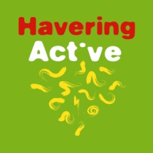
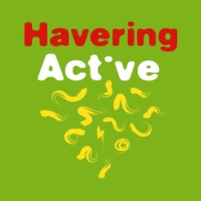
45+ Physical Week
ARCHERY TOURNAMENT
Results
Gentlemen recurve Gentlemen Compound
1 Ian Bushell Rayleigh 864 1 John Raffin Noak Hill 950
2 Ian Clampin West Essex 862 Gentlemen Longbow
3 Kevin Sykes West Essex 860 1 Eric Mallet Abbey 574
4 Clive Atkinson Ascham 836 2 Mark Lawrence Pilgrim 473
5 Lee Ayres Abbey 832 3 Max Room Noak Hill 429
6 Mark Billing Abbey 829 4 Norman Lee Abbey 310
7 Barry Brown Abbey 802
8 Adrian Charlemagne West Essex 781 Ladies Recurve
9 Andy Rae Abbey 754 1 Susi Atkinson Ascham 874
10Joe Cordaro Abbey 738 2 Sharon Lawrence Pilgrim 814
11Dave Wiltshire Abbey 689 3 Sheila Easton Noak Hill 641
12 Steve Watts Abbey 366

Married Couple Over 65 Recurve
1 Susi & Clive Atkinson Ascham 1710 1 Ian Bushell Rayleigh 864
2 Sharon & Mark Lawrence Pilgrim 1287 2 Kevin Sykes West Essex 860
3 Barry Brown Abbey 802
Junior Windsor Gents Recurve 4 Dave Wiltshire Abbey 689
1 Albert Fenton Ardleigh 366

Junior Windsor Ladies Longbow Junior Windsor Ladies Recurve
1 Maggie Pearce West Essex 350 1 Pam Freestone Ardleigh 572

Best Gold – Longbow – Mark Lawrence, Other bow styles – Dave Wiltshire
Worst White – Longbow – Max Room, other bow styles – Albert Fenton

Special thanks must go to all the members of Abbey Bowmen for all of their help both on the day and prior to the tournament.
To the ladies of Abbey Bowmen, in particular, who kept us so well fed and watered throughout the day.

To our Judges for the day Mr Mick Pearce & our Lady Paramount, Mrs Maggie Pearce

And lastly, but by no means least to everyone who turned up and made it such an enjoyable and successful day.

Many Thanks; Vince Gorham– Organiser

