On Friday we drove up to the Junior National Outdoor Championships to compete on my England debut. We left ourselves plenty of time to get to Lilleshall National Sports Centre.
Upon arrival, we had the usual parental fight for the line, but we sneakily took a side route as Dad would have taken half the people out with the tent on his back, looking like a Teenage Mutant Ninja Turtle. Tent set up, time for practise. Got my sight marks in at 40m and was happy considering the arrows were going in groups the size of a tennis ball.
7pm we had our Team England meeting with our Managers Tyler Fife and Vikki Louise Mara. Tyler explained what was going to happen and how it would all be worked out and I got to know my team mates that I hadn’t met before. I received my England kit, which fitted perfectly and a surprise England Gilet which I was not expecting.
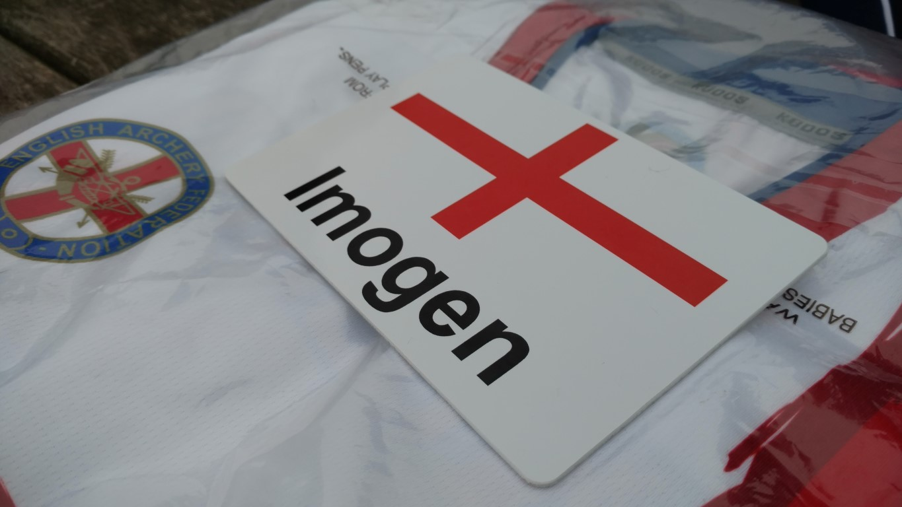
Earlyish bed so I would be ready for the Saturday event and be at my best.
Saturday held the Home Nations, England v Scotland v Northern Ireland v Wales, the Home Counties, so Southern v Midlands v North etc and would be contested over the Metric rounds, so for me, Metric IV. 144 arrows, 3 dozen at each distance, 40m, 30m, 20m, 10m with the target set at 122cm wide, narrowing to 80cm at 20m and 10m.
The weather was overcast and a little chilly in the morning, but I had a job to do. Luckily the wind was surprisingly light…very unlike Lilleshall I have to say.
I knew this would be a tough event, with some of my main rivals competing for the individual title as well as some competing for the other nations. This included my friends Penny Healy, Charlotte Hampsall (ENG), Caitlin Aiken (SCOT) amongst others.
So 40m, started well, opening with a 54 (max is 60) and followed up with a 51, 51, 53 (I hit a 6 and a 7 in that lot ) but finished strong with 56 and 56, ending the distance on 321. 30m was really good but not good enough. My competitors were on form. I shot well though, 57, 55, 58, 57, 54, 51 (another 6), so now at 653 I was 12 points behind in 3rd place. Those pesky 6’s!
Now the target shrinks to 80cm…game changer. Dad said I have relax my release and be more gentle on the shot. So with this in mind I tried my best to run the process and pull on my strength and resolve to claw the points back. 56, 58, 59, 57, 58, 59 BOOM! I was now 4 points ahead, so nothing but a flawless last distance to seal the victory.
At this point my Team manager Tyler came up to see me and Charlotte and tell us that the Home Nations match rested on our shoulders…no pressure then, thanks Tyler! However, I knew what I had to do. “Flawless shots now” dad said…flawless is what I gave him. 60, 60, 60, 60, 60, 60 ending the event on 1360, as the UK Ladies U14 Recurve Champion, a new PB, National 10m Record, four County Records, Club Record…what more could I want? The Home nations!
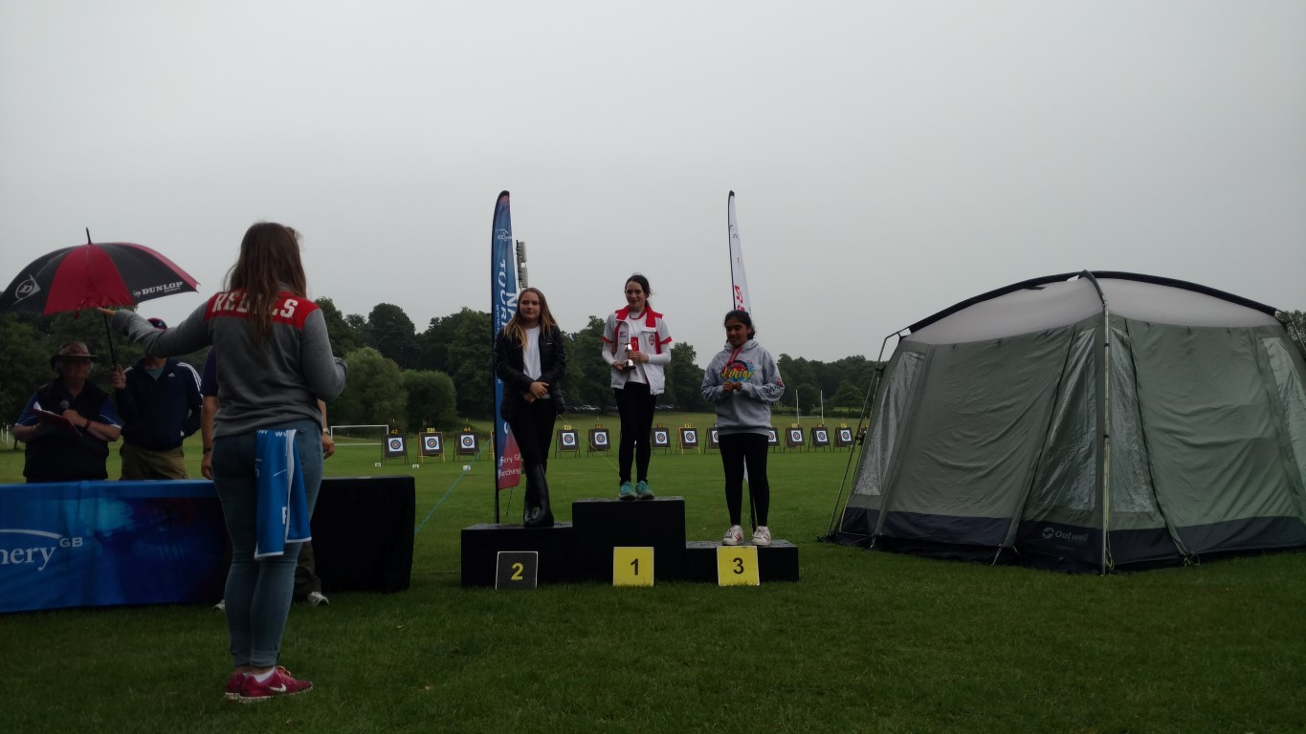
We all gathered for results to be called out and I collected my medal and trophy, sorry Dad another one to engrave. In the Home Nations, Wales were called in 3rd place, then Scotland in 2nd place and the England in 1st! You’ve never heard so many cheers and screams! I was so happy. The regionals were also announced and I was in the SCAS (Southern Counties) team as a high scorer which SCAS won also!
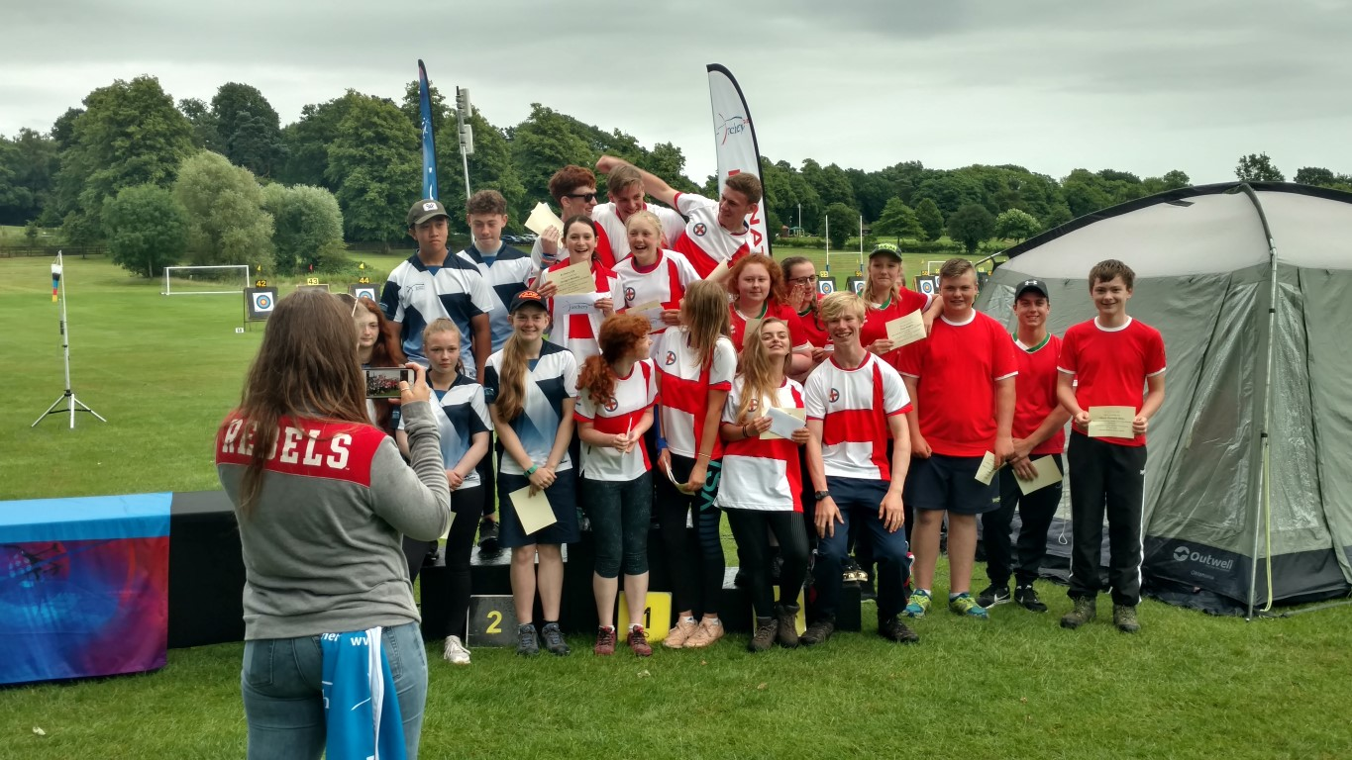
Excitement over, we went for our team photos victorious!
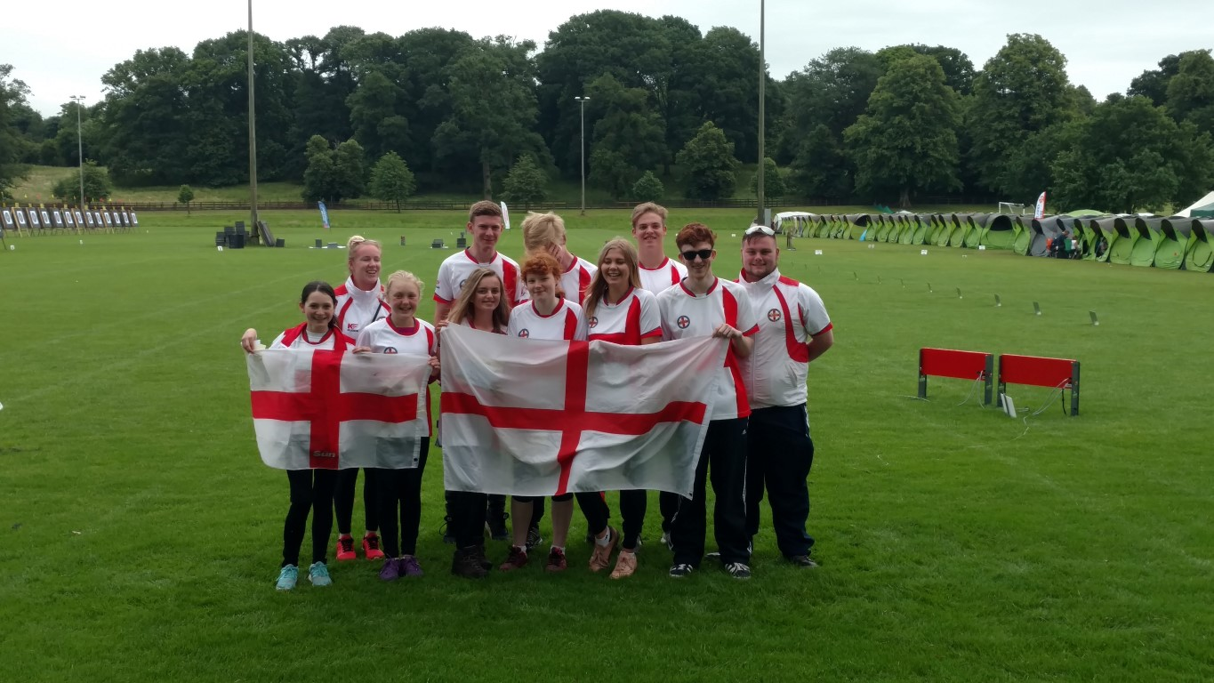
Home, dinner, bed….I was so tired I didn’t even finish my dinner, I just went to bed.
Sunday early call at 6am by Dad, quick shower, and then my usual porridge and fruit to set me up for another long day. This one was all for me. Bristol IV, 6 dozen and 40 yards, 4 dozen at 30 yards and 2 dozen at 20 yards all on a 122cm face. I knew today had to be perfect, this is easier than the Metric.
The day was dry unlike yesterday but windy! A tricky moving head wind to deal with. Dad said to focus and the wind flags and make my judgements according to the wind direction and just feel it. I started really well. Max score per end is 54. I scored 52, 52, 54, 54, 54, 52, I had a 12 point lead…things couldn’t have gone better then I hit a 5, scoring 44 then a 46, 52 then a 44. My heart sank, adrenalin kicked in and I had to dig deep to stop the point loss as I was now 8 points behind in 3rd. The wind continued to play tricks on us all and I finished the distance with 52, 44 (I hit a 3), 50 and 50. Not bad but not great.
30 yards, this has got to be good. I cannot afford any more slip ups. No slip ups from this one…54, 54, 54, 54, 52, 52, 52, 54…hello, back in the game with a 4 point lead! Now nothing but a perfect round could seal this off…20 yards was flawless, 54, 54, 54, 54, ending the day victorious and 1246. New PB, new County Record…I was over the moon. I worked so hard, my back was aching, my shoulder was giving me jip, but happy to be all over.
I’m the Double UK Ladies U14 Recurve Champion 2017! Doesn’t get much better than that!
Thank you to everyone that supports me in my pursuit for my Olympic dreams. This is a great stepping stone. Thanks to my Mum who does all my washing, feeds the right foods and cleans up after me, thanks to my coach Tony for all his patience and guidance; thanks to my sponsors Aim4Sport for their expertise on equipment and facilities, Leon Stephens at Sudbury Physiotherapy Centre in Sudbury for looking after me, Dales Hair Salon for looking after my hair (SO important) and Chadwick Teamwear for providing me with technical clothing to train and compete in.
