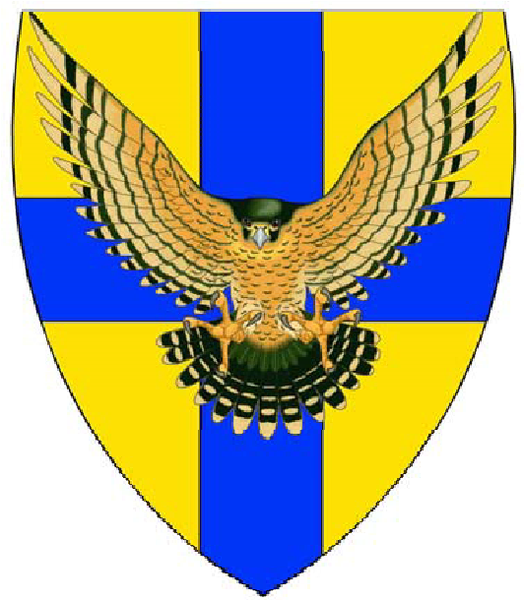
Noak Hill Archers
UK Record Status Westerns
Saturday 23rd May 2020

Venue: Noak Hill Archers, Grange Road, Heaton Grange, Romford, Essex RM3 7EA
Chair of Judges, Mr Richard Pilkington
Lord/Lady Paramount:- to be confirmed
Rounds: New Western (NW), Long Western (LW), Western(W), Short Western (SW),
Junior Western (JW), Short Junior Western (SJW)
Assembly: 09:45 am
Sighters: 10:00am
Awards: According to entry
Dress Code: Archery GB dress regulations will be strictly applied, Rule 307
Entry Fee: Seniors £10, Juniors £8
Cheques only and payable to “Noak Hill Archers” and must be submitted with entry form
Entry Forms and cheques to:
Mark and Sharon Lawrence
20 Dagnam Park Close
Romford
Essex
RM3 9YL
E-mail mark-l@talk21.com or sharon_lawrence@talk21.com for any queries
Closing date for entry: Monday 18th May 2020

Title | Surname | Forename | S/J | M/F | Round | Style | Archery GB No. | Fee
 |  |  |  |  |  |  | Total | £
Club:___________________ E-mail: _______________________
Contact Name and phone No. ____________________________________________
Target list and results will be published on the County and club website

Food and drinks will be available all day

Testing Consent
As stated on the entry form, this Western is a record status shoot and thus subject to drug control regulations. Failure to produce a specimen when requested by the appropriate authorised official will be treated as a positive result.
This form must be completed for all juniors taking part in the competition, authorising the provision of a specimen should it be requested
Name of Competitor | Signature of Parent/Guardian

General notes: Archers should note that they will be asked to produce their Archery GB cards, failure to so will mean you will be unable to shoot.
Any archers with a physical impairment to state if they shoot from a wheelchair or stool and if they need to stay on the shooting line to the tournament organiser
Photography:
Anyone who intends to take photographs, with camera or phone, will only be allowed to if they have first registered with the organisers.
The organisers reserve the right to refuse any person entry to the grounds. The tournament organisers, not the judges, will be responsible for dress regulations, anyone refused entry or removed from the grounds will not have their entry fee refunded.
Crossbows not permitted
GDPR
When you enter competitions the following information may be collected and shared with tournament organisers, scoring systems and other competitors for example target lists and results may be published: First Name, Surname, Gender, Bow style, Date of Birth / Age category, Email, Address, Phone number, Club (and ID), County (and ID), Region (and ID), Round (unless defined by age), Disabled (Y/N), Disability info.
Disclaimer: -Juniors: All clubs and parents/legal guardians of participating juniors are reminded of their obligations and legal responsibilities under the provisions of the Protection of Children and Young Persons Act. Neither Noak Hill Archers or Essex and Suffolk Water Company, their agents or servants shall be responsible for the safety or well being of any person defined under the C P&Y act. No child or young person as defined by the Act shall be permitted to enter or shoot on the range or grounds unless accompanied and supervised at all times by a parent/legal guardian or an appropriate adult who must be able to produce on demand by the organisers or any other lawful authority, a written authorisation from the parent/legal guardian granting supervisory custody. An appropriate adult is a person defined as such by the Act. For guidance regarding these matters, please refer to the guidelines issued by Archery GB. Signed copies of written authorities must be returned with entry forms.

Disclaimer:- General: Noak Hill Archers, their agents or servants will accept no responsibility for vehicles on the ground or injury to any persons or loss or damage to equipment or visitors howsoever caused.

